Incident 27820

Customer test environment - my357965.sapbydesign.com

SIV – 1080310

Posted from backend posts successfully, but when clicked on save throws error - "Region 020 does not exist"

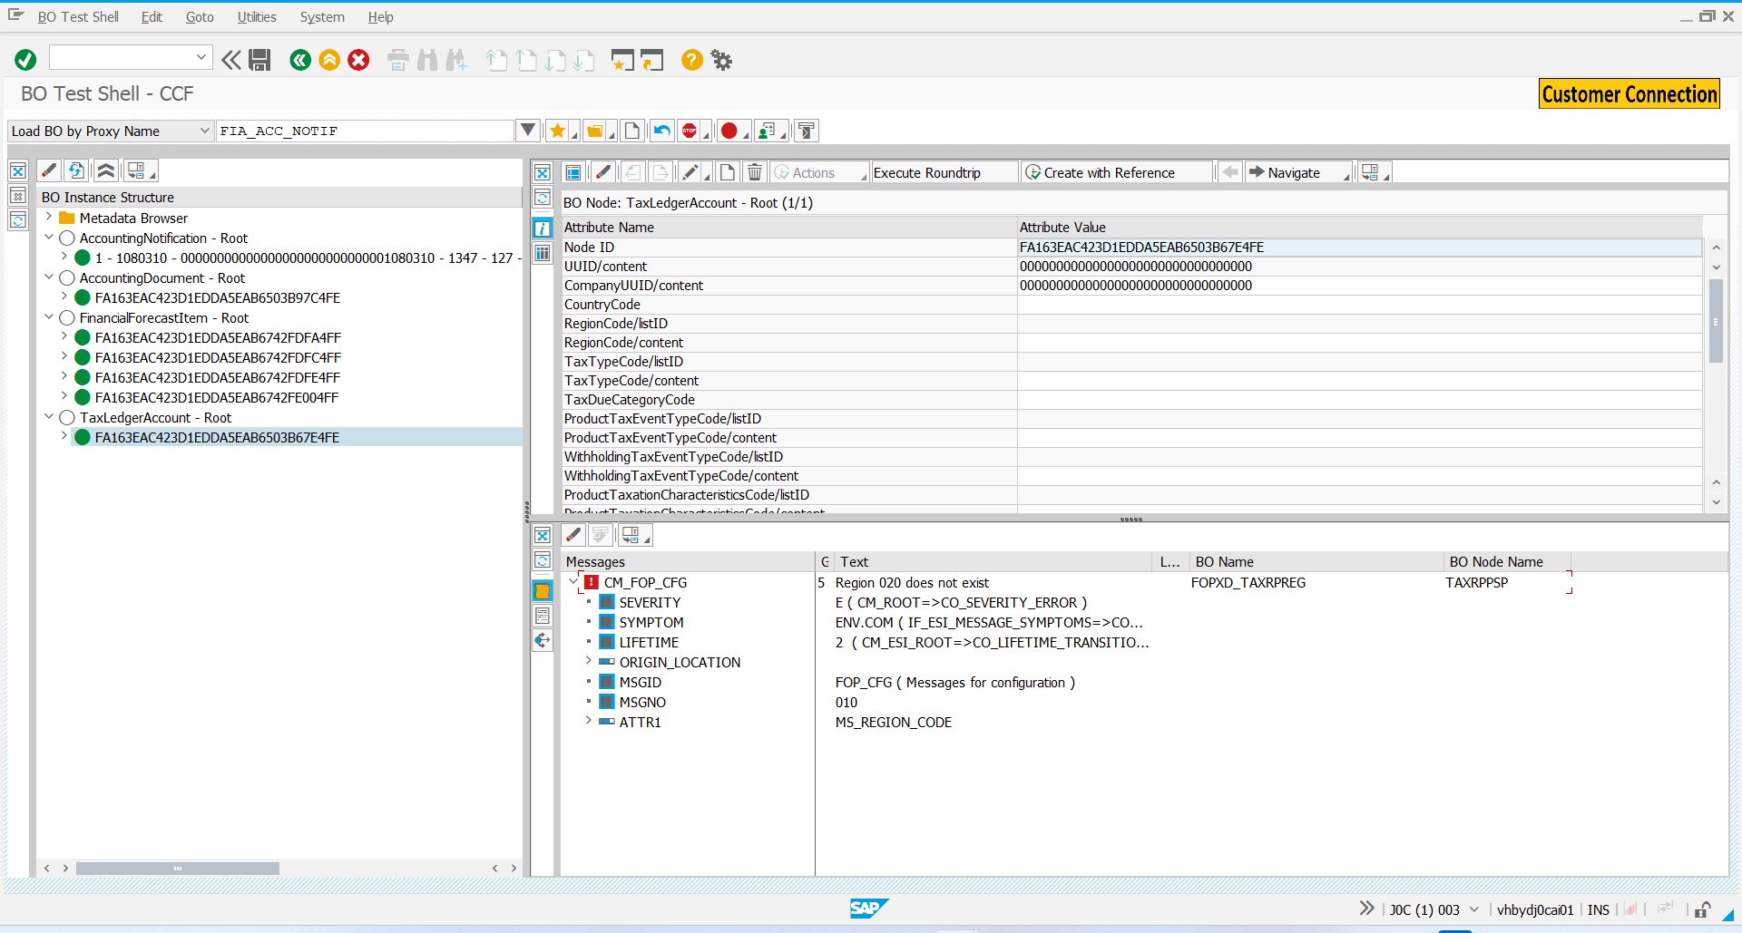

Error message class and message ID - FOP_CFG ( Messages for configuration ) , 010

In front end for Item 1 the Tax country /Region is CA-CANADA, but the Tax Region is 020 (Shanghai)

In changes we could see Tax country was changed from China to Canada for SIV.

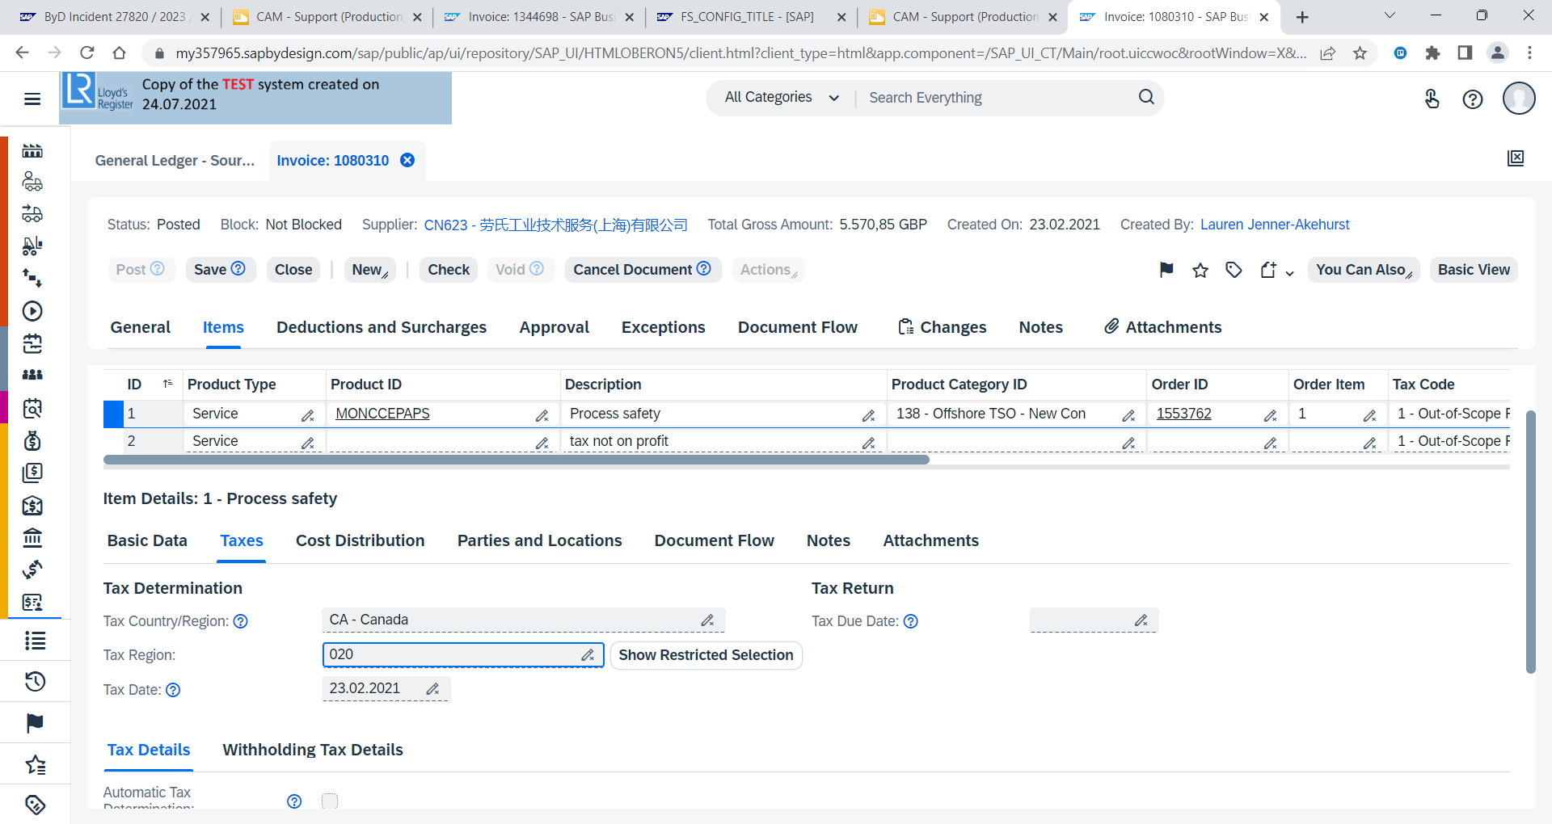

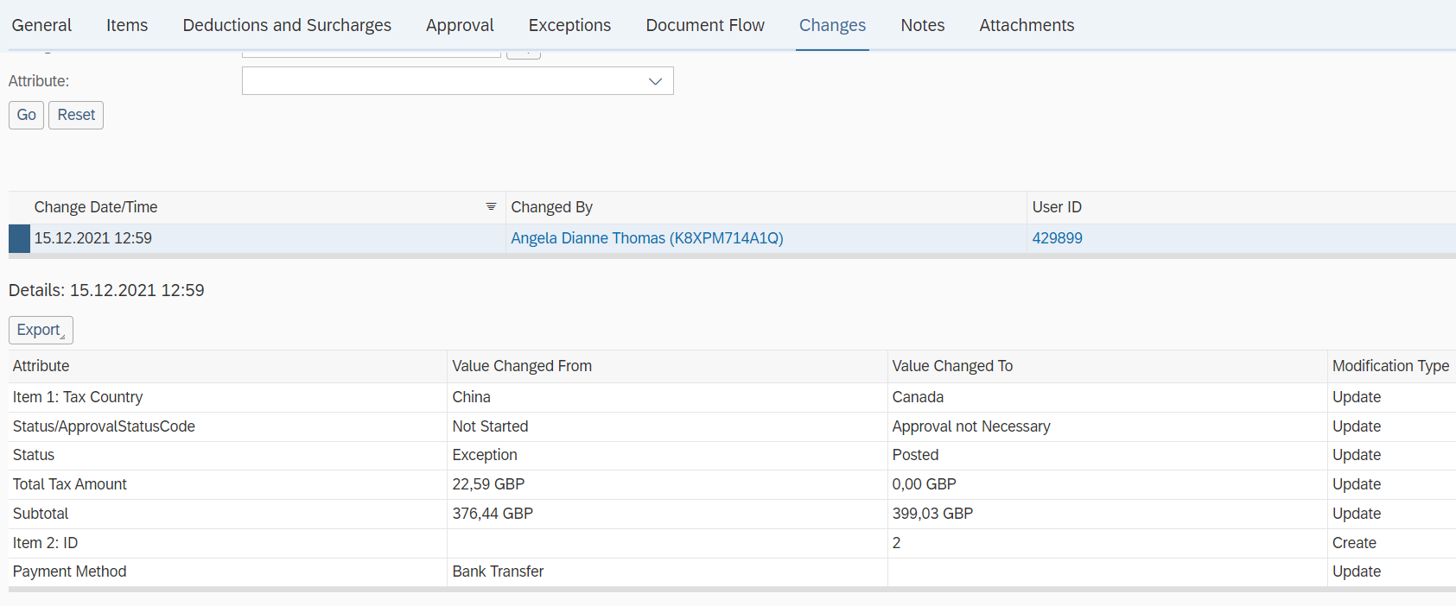

Debugged and found the class and method where error takes place

Class - CL_FOP_VAL_TAXRPPSP_CODES

method - /BOPF/IF_FRW_VALIDATION~EXECUTE

Line – 97

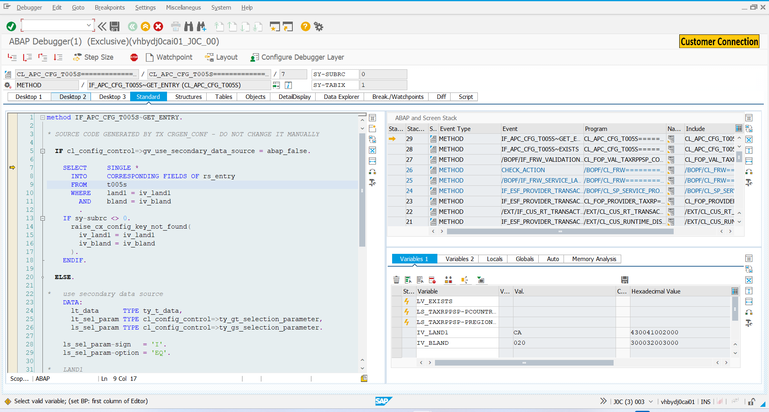

In test shell the value is 020, but in help search it shows only NS – Nova Scotia (which is correct tax region)

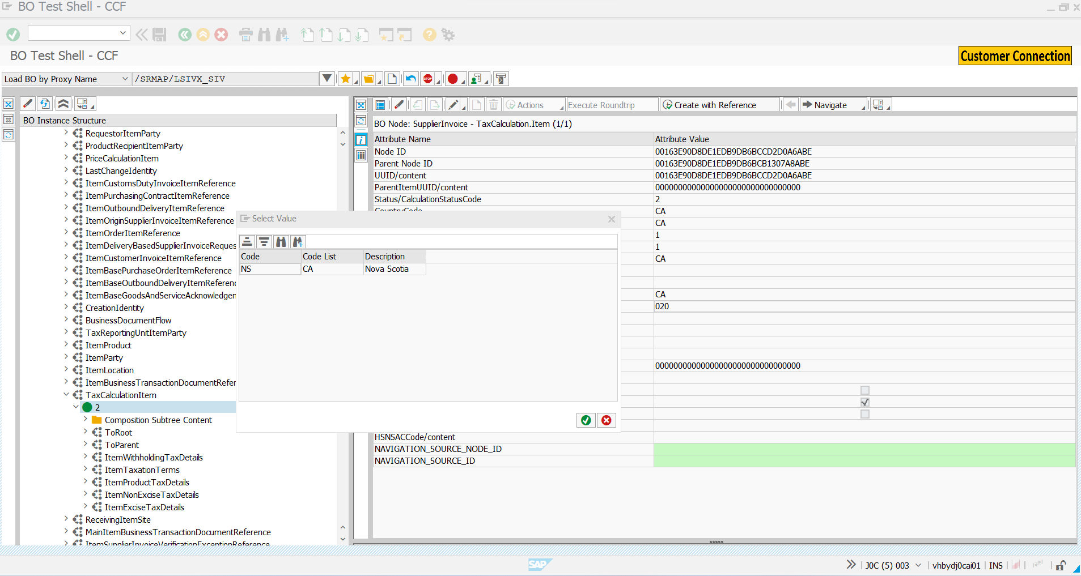

Table T005s shows correct assignment of the tax region for CA (CANADA)

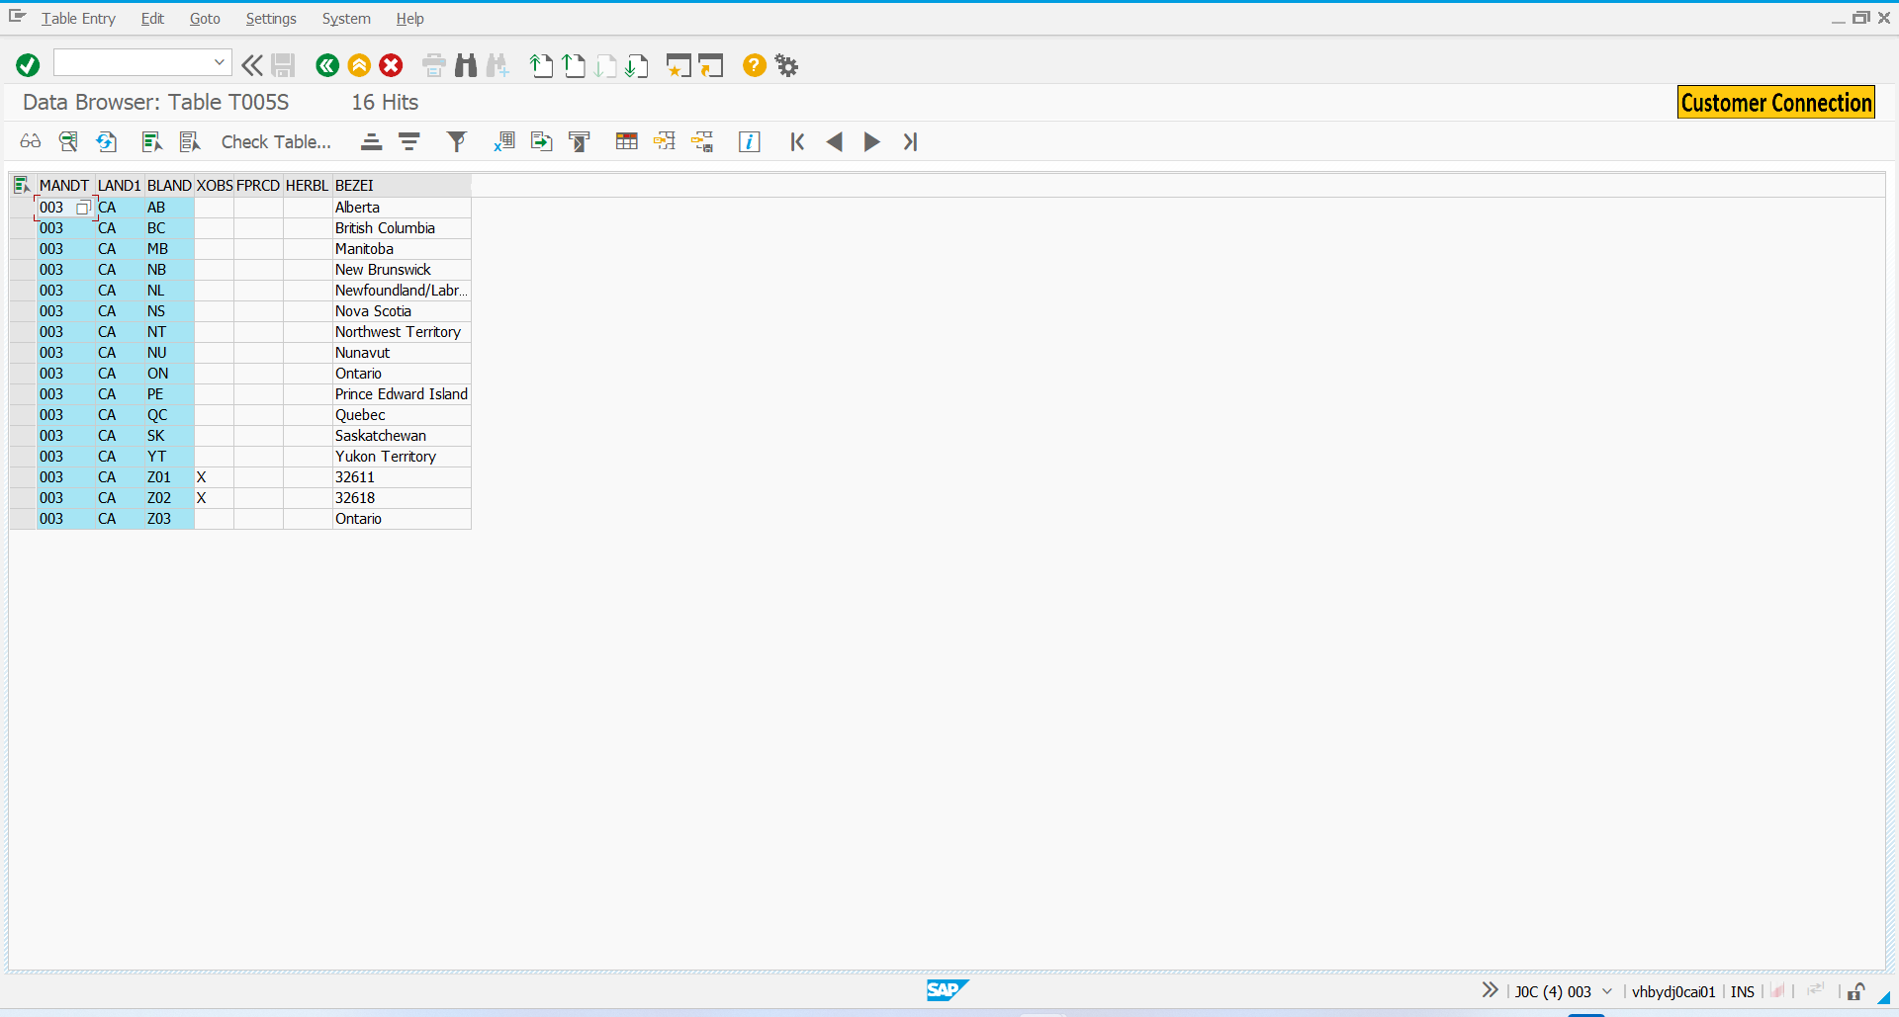

And 020 is erroneous which is for Shanghai.

